**Модуль 5 – Практикум (75 баллов)**

**Блок 1 (19 баллов)**

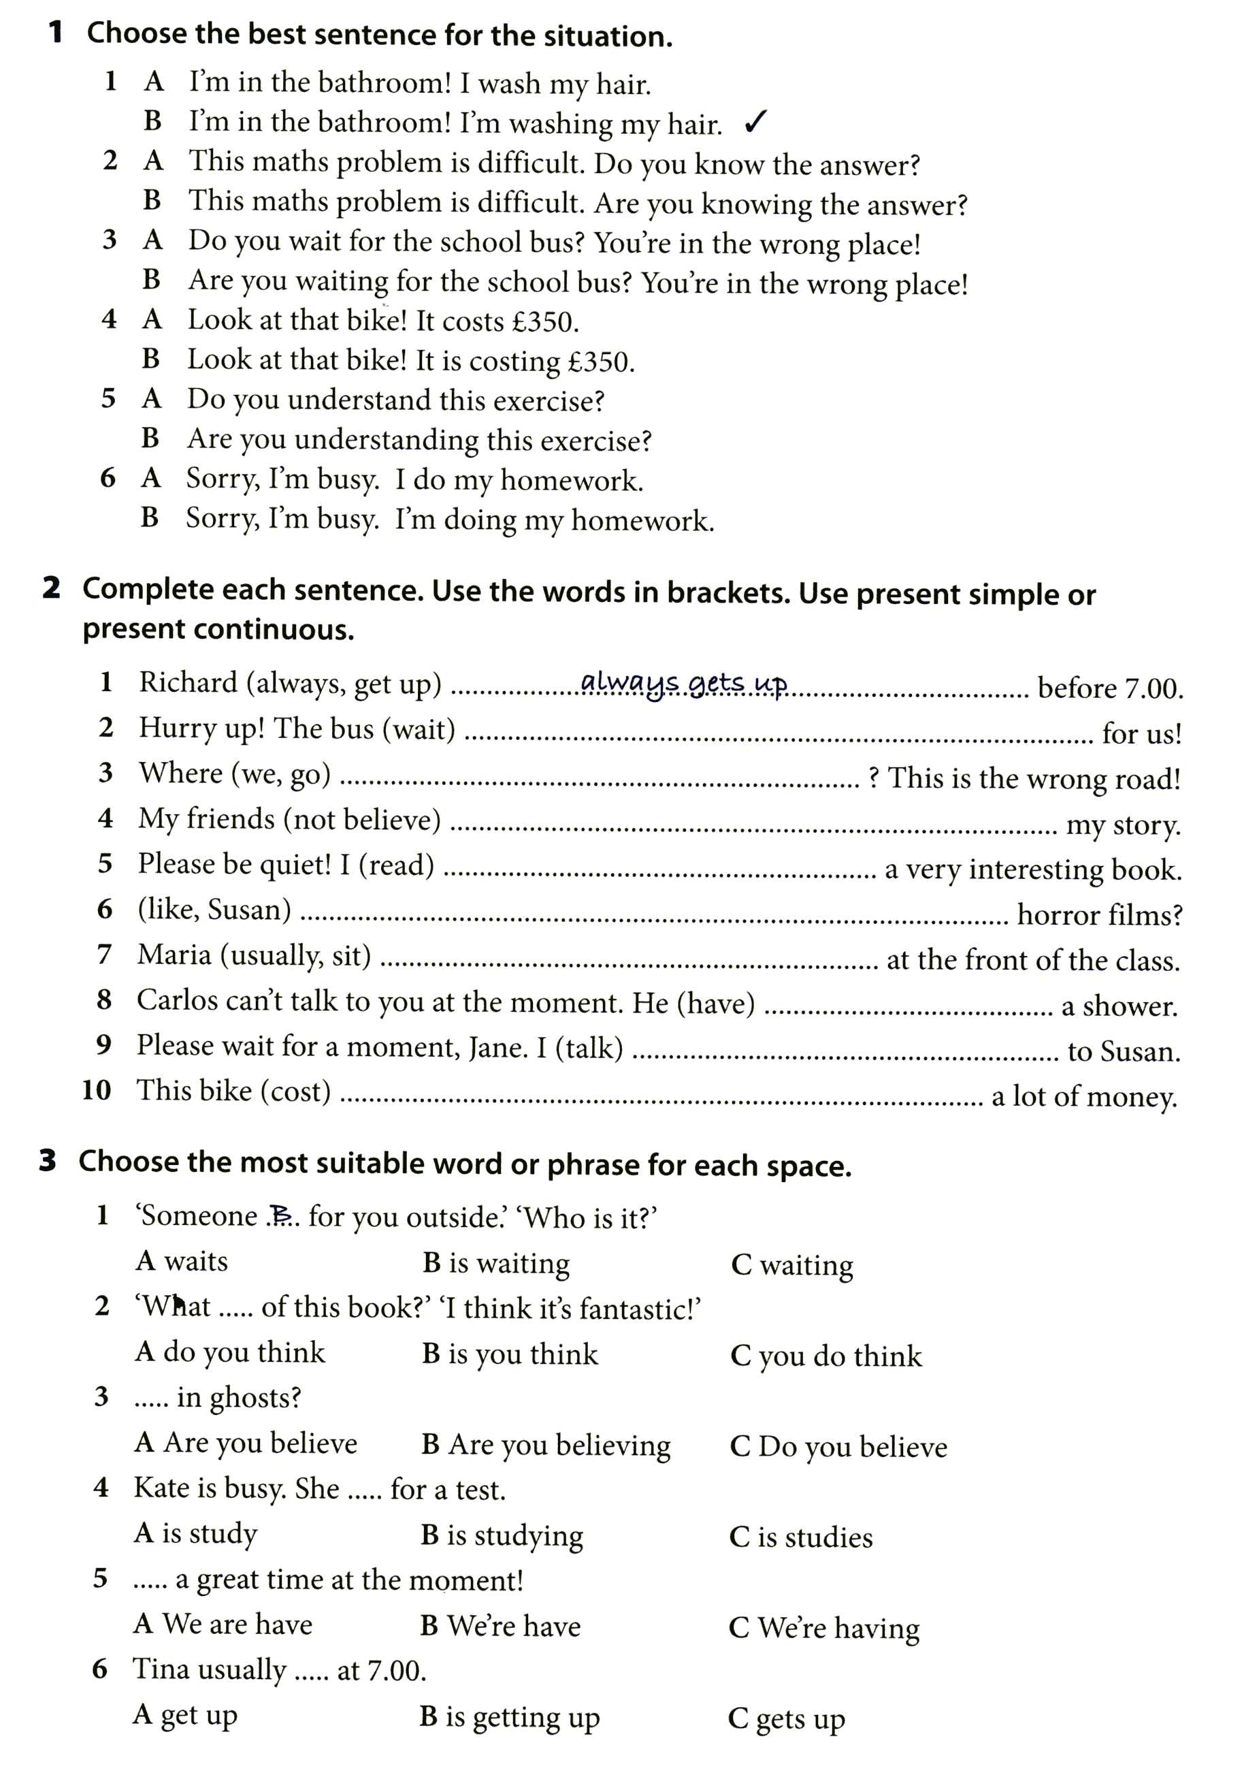

**Блок 2 – 31 балл**

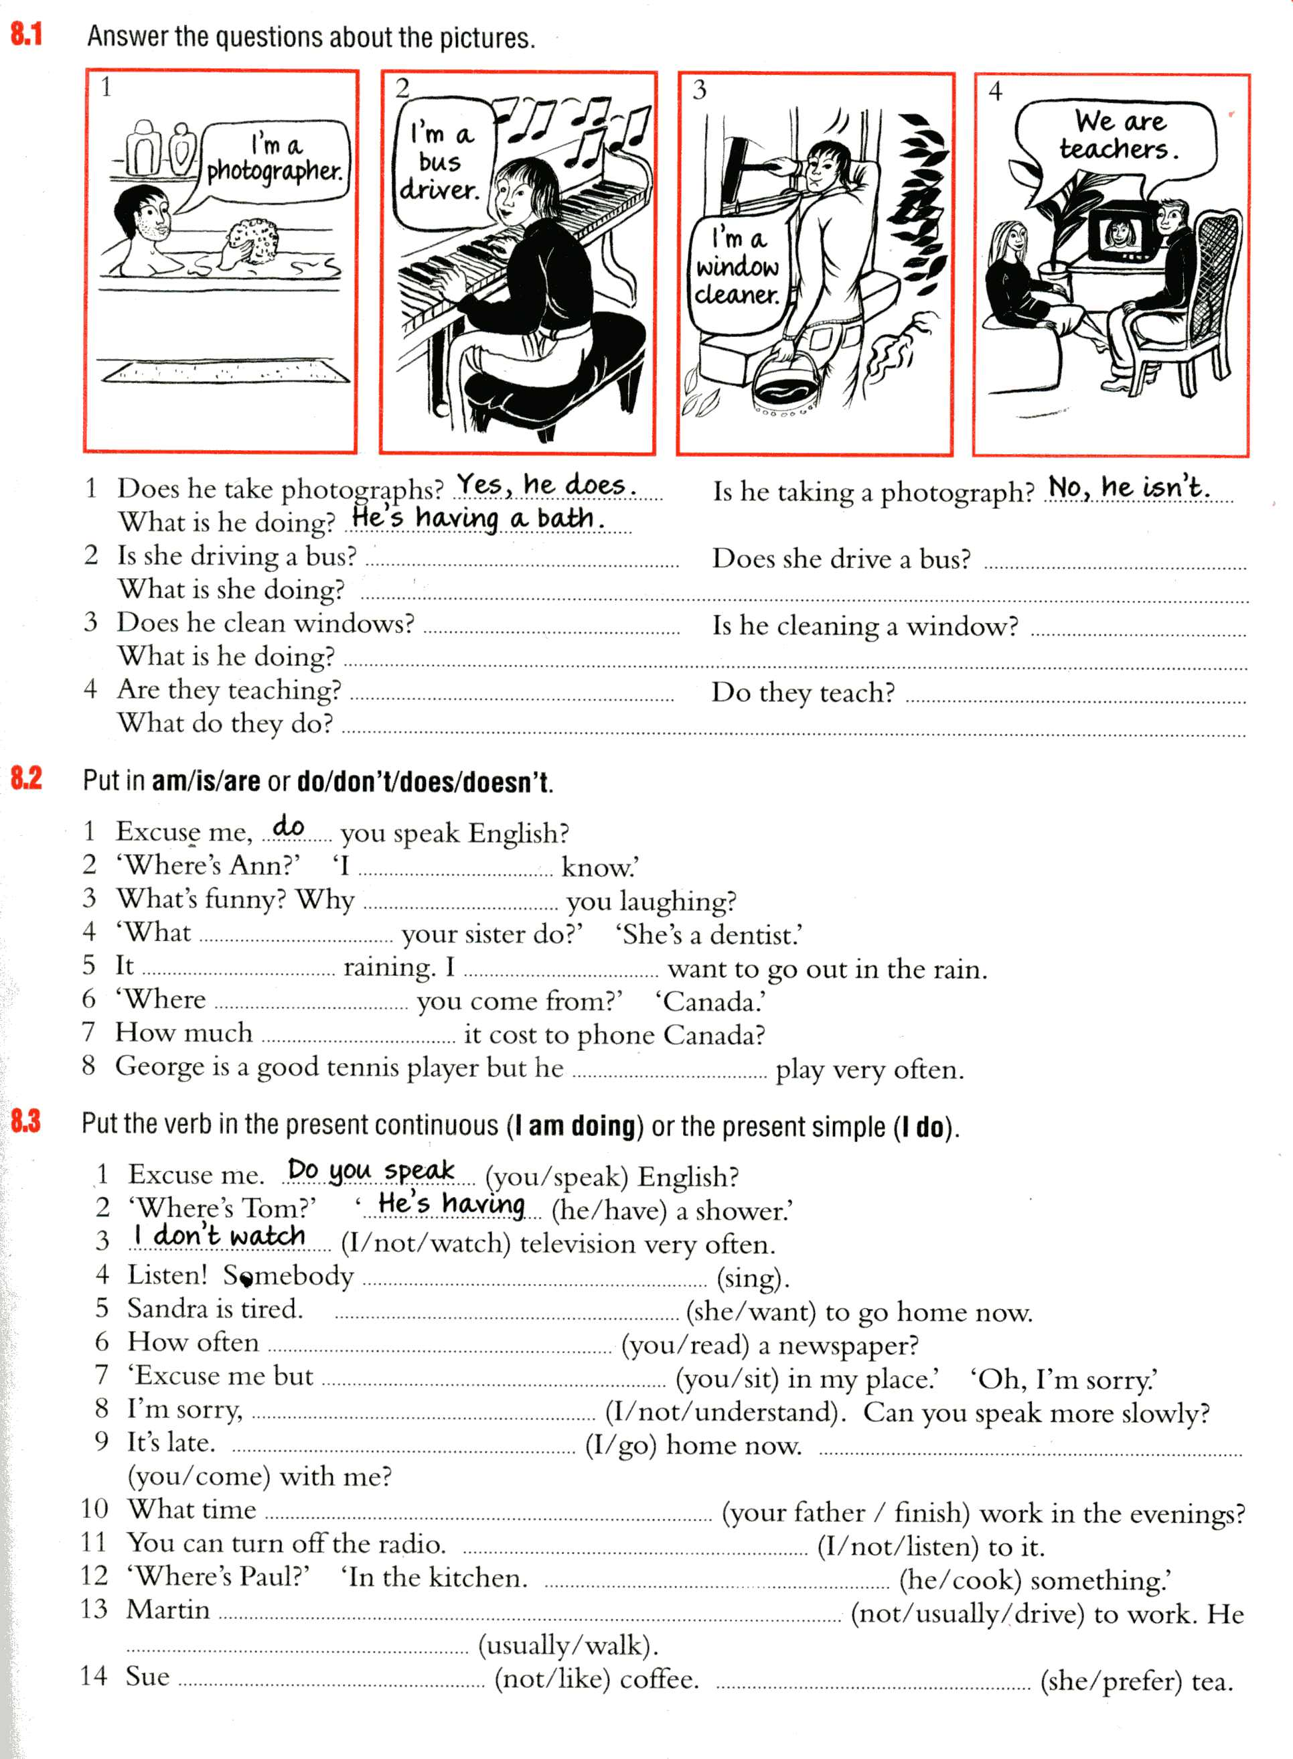

**Блок 3 (25 баллов)**

***1. Put the verbs into the correct form, the Present Continuous or Present Simple***

1. Please don't make so much noise, I (study). 2. How many languages Tom (speak)? 3. This machine (not /work). It hasn't worked for years. 4. I (not /belong) to a political party. 5. Hurry! The bus (come), I (not /want) to miss it 6, The River Nile (flow) into the Mediterranean. 7. The river (flow) very fast today - much faster than usually 8. (it/ever/ snow) in India? 9. We usually (grow) vegetables in our garden but this year we (not/ grow) any. 10. Can you drive? - No, but I (learn). My father (teach) me. 11. You can borrow my umbrella. I (not/ need) it at the moment 12.I usually (enjoy) parties but! (not/ enjoy) this one very much. 13. George says he is 80 years old but I (not/ believe) him. 14. Ron is in London at the moment He (stay) at the Hilton Hotel He usually (stay) at the Hilton Hotel when he is in London. 15. My parents (live) in Bristol. They were born there and have never lived anywhere else/Where your parents (live)?

***2. Use Present Simple or Continuous***

1. I rarely (wear) a tie in summer, but I (wear) one now. 2. Me (to do) this exercise now. We (do) two exercises every lesson. 3. George (smoke) a cigarette. He (smoke) ten cigarettes a day. 4. Come in, I (have) a cup of tea. I usually (have) one about this time.5. What you (do) this evening? - I generally (knit) or (sew) , but this time I (watch) TV.6. The postman (walk up) the path. He (come) twice a day. 7. The telephone (ring). Someone (want) to talk to you. 8. What (be) this dreadful smell? Something (burn) in the kitchen. 9. How Peter (get) on at school? - Very well. He (seem) to like the life. 1O. Why Mum (look) so angry? - Father (smoke) a cigarette & (drop) the ash on the floor.